**10.1 Social Behavior\***

Attraction

* Is what makes people like each other and is influenced by multiple factors

1. Physical attractiveness, golden ratio
2. Similarity of attitudes, intelligence, education, height, age, religion, appearance, and socioeconomic status
3. Self-disclosure
   1. Includes sharing fears, thoughts and foals with another person
   2. Must be met with non-judgmental empathy
4. Reciprocity
5. Proximity

Aggression

* A physical, verbal, or nonverbal behavior with the intention to cause **harm** or increase **social dominance**

1. Biological perspective
   1. Parts of the brain
      1. Amygdala activated → increases violence
      2. Prefrontal cortex can place brakes (hence, reduced activity in this area is linked to increased aggressive behavior)
   2. Hormonal control
      1. Higher levels of testosterone → more aggressive behavior in both males and females
2. Psychological and situational predictors
   1. Cognitive neoassociation model
      1. We are more likely to respond to others aggressively whenever we are feeling negative emotions e.g. being tired, frustrated or in pain
      2. E.g. riots more likely to happen on hot days than cool days
   2. Exposure to violent behavior
      1. E.g. media portrayals of violence

Attachment

* Emotional attachment between a caregiver and a child

1. Secure attachment
   1. Requires a **consistent** caregiver so the child is able to go out and explore, knowing he or she has a secure base to return to
   2. The child will show **strong preference** for the caregiver
2. Avoidant attachment
   1. Occurs when a caregiver has **little or no response** to a distressed, crying child
   2. The child shows **no preference** for the caregiver compared to strangers
3. Ambivalent attachment
   1. Occurs when a caregiver has an inconsistent response to a child’s distress, sometimes responding appropriately, sometimes neglectful
   2. The child will become **distressed when caregiver leaves** and is **ambivalent** **when he or she returns**
4. Disorganized attachment
   1. Occurs when a caregiver is erratic or **abusive**
   2. The child shows **no clear pattern** of behavior in response to the caregiver’s absence or presence and may show repetitive behavior

Social Support

* The perception or reality that one is cared for by a social network

1. Emotional support
   1. Listening to, affirming, and empathizing with someone’s feelings
2. Esteem support
   1. Affirms the qualities and skills of the person
3. Material support
   1. Providing physical or monetary resources to aid a person
4. Informational support
   1. Providing useful information to a person
5. Network support
   1. Providing a sense of belonging to the person e.g. group activities

Social Behaviors and Evolutionary Fitness

1. Foraging
   1. Searching for and exploiting food resources
   2. Sensation of hunger controlled by hypothalamus
      1. LH promotes hunger
      2. VMH promotes satiety
   3. Impacted by genetics
      1. Forage together vs solitary foraging
   4. Cognitive skills
      1. Spatial awareness
      2. Memory
      3. Decision making
2. Mating and Mate choice
   1. Mating system describes the way in which a group is organized in terms of sexual behavior
      1. Monogamy
      2. Polygamy
         1. Polygyny (male with multiple females)
         2. Polyandry (female with multiple males)
      3. Promiscuity
   2. Mate choice, or intersexual selcection, is the selection of a mate based on attractiveness
      1. Phenotypic benefits
         1. **Observable traits** that make a potential mate more attractive
         2. E.g. males that appear more nurturing
      2. Sensory bias
         1. Development of a trait to match a **preexisting preference** that exists in the population
         2. E.g. male fiddler crabs build pillars around their territory to attract mates (because fiddler crabs are naturally attracted to structures that break up the level horizon)
      3. Fisherian or runaway select
         1. A positive feedback mechanism in which a particular trait that has no effect or a negative effect on survival becomes more and more **exaggerated** over time
         2. E.g. plumage of the peacock
      4. Indicator traits
         1. Traits that signify overall good health and well-being of the organism
         2. E.g. female cats are more attracted to male cats with clean and shiny coats
      5. Genetic compatibility
         1. The creation of mate pairs that, when combined, have complementary genes
         2. E.g. attracted to others who have starkly different genetic makeups → reduces probability of offspring being homozygous recessive for disease allele
3. Altruism
   1. A form of helping behavior in which the person’s intent is to benefit someone else **at some cost to him- or herself**
   2. Can be motivated by:
      1. **Selflessness**
      2. Egoism or ulterior motives e.g. public recognition
      3. Empathy
4. Game theory
   1. Attempts to explain decision-making between individuals as if they are participating in a game
   2. Four possible alternatives
      1. Altruism: The donor provides a benefit to the recipient at a cost to him- or herself
      2. Cooperation: Both the donor and recipient benefit by cooperating
      3. Spite: Both the donor and recipient are negatively impacted
      4. Selfishness: The donor benefits while the recipient is negatively impacted
5. Inclusive fitness
   1. A measure of an organism’s success in the population based on:
      1. The number of offspring
      2. Success in supporting offspring
      3. The ability of the offspring to then support others
   2. Inclusive fitness promotes the idea that altruistic behavior can improve the fitness and success of a species as a whole
      1. Close relatives on an individual will share many of the same genes → promotes the reproduction and survival or related or similar individuals
      2. Sacrificing themselves to protect the young → these organisms ensure the passing of genes to future generations

**10.2 Social Perception and Behavior**

Social Perception

* Also referred to as social cognition, and provides the tools to make judgments and impressions regarding other people
* Components
  + Perceiver
    - Influenced by experience, motives, and emotional state
  + Target
    - The person about which perception is made
  + Situation
    - Social context of the scenario
* Impression bias
  + Implicit personality theory
    - People make assumptions about how different types of people, their traits, and their behavior are related → stereotype (based on category)
* Cognitive bias
  + Primacy effect
    - First impression matters more
  + Recency effect
    - Most recent information we have about an individual matters more
  + Reliance on central traits
    - Tendency to organize the perception of others based on the traits and **personal characteristics that matter to the perceiver**
  + Halo effect
    - When judgments of an individual’s character (specific) can be affected by the overall impression of the individual (general)
    - E.g. More attractive people (general) are more likely to be trustworthy and friendly (specific)
  + Just-World hypothesis
    - Tendency of individuals to believe that good things happen to good people, and bad things happen to bad people
  + Self-serving bias
    - Individuals will view their **own successes as being based on internal** factors, while viewing **failures as being based on external factors**
    - Influenced by:
      * Motivational process e.g. self-enhancement (focus on the need to maintain self-worth)
      * Cognitive process e.g. locus of control
      * Emotion

Attribution Theory

* Focus on the tendency for individuals to infer the causes of other people’s behavior

1. Causes
   1. Dispositional (**internal**)
      1. Related to the features of the person whose behavior is being considered
      2. E.g. believing that your friend got the award because of his own hard work
   2. Situational (**external**)
      1. Related to the features of the surroundings or social context
      2. E.g. believing that your friend got the award because of luck
2. Cues
   1. Consistency
      1. Consistent behaviour of the person over time
      2. More regular → dispositional attribute
   2. Consensus
      1. The extent to which a person’s behavior differs from others
      2. Deviates → dispositional attribute
   3. Distinctiveness
      1. Extent to which a person uses similar behavior in similar situations
      2. Vary → situational attribute

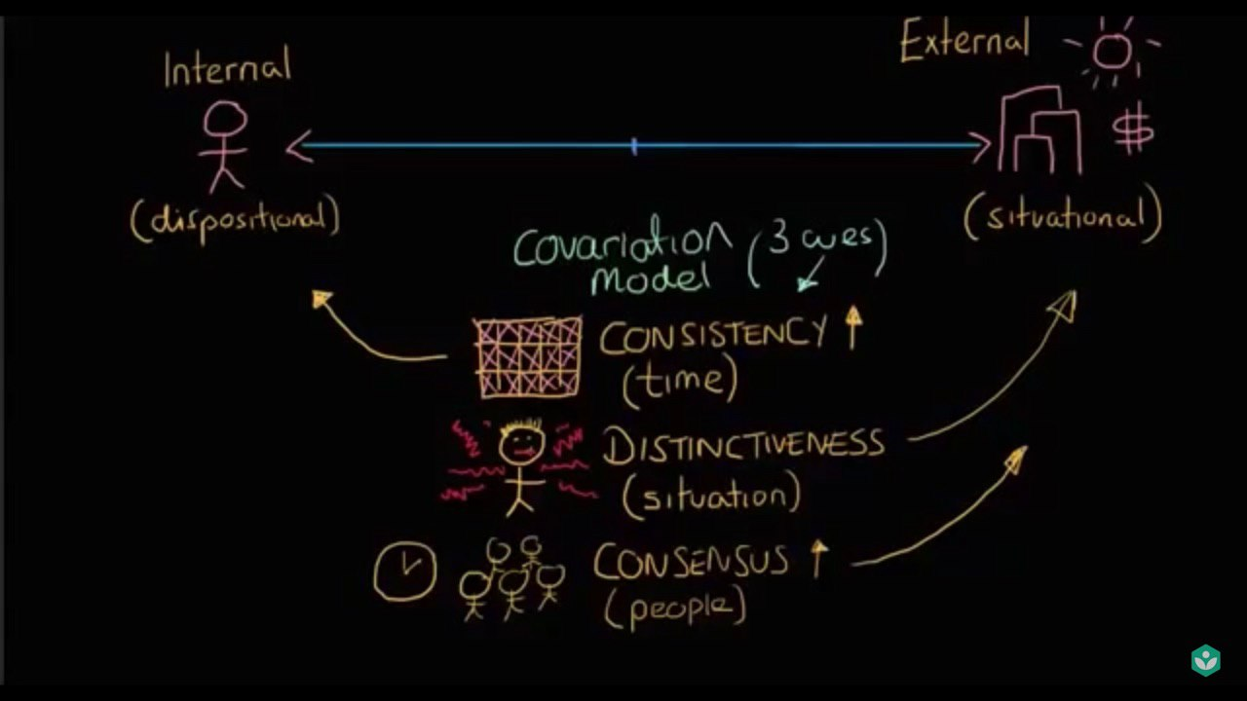

* 1. Correspondent inference theory
     1. Used to describe the attributes made by observing the intentional (esp unexpected) behaviors performed by another person
     2. We tend to explain the behavior by dispositional attribute

1. **Fundamental attribution error**
   1. **Bias toward making dispositional attributes rather than situational attributes in regard to the actions of others, especially in negative contexts**
   2. E.g. when a teammate did not complete his part, we immediately assume that he is lazy, unreliable or even stupid (dispositional attributes), and ignore the possibility that he might be ill or suffered a personal tragedy (situational attributes)
2. Attribution substitution
   1. Occurs when individuals must make judgments that are complex but instead substitute a simpler solution or heuristic
   2. E.g. Most individuals tend to answer that cube takes up 74% of a sphere (3D) because a square takes up roughly that amount of space (~79%) in a circumscribed circle (2D); the correct answer is only 52% in 3D
3. Cultural attribution
   1. Individualistic cultures tend to attribute success to internal factors, and failures to external factors (They are more likely to commit self-serving bias too)
   2. Collectivist cultures tend to attribute success to external factors, and failure to internal factors

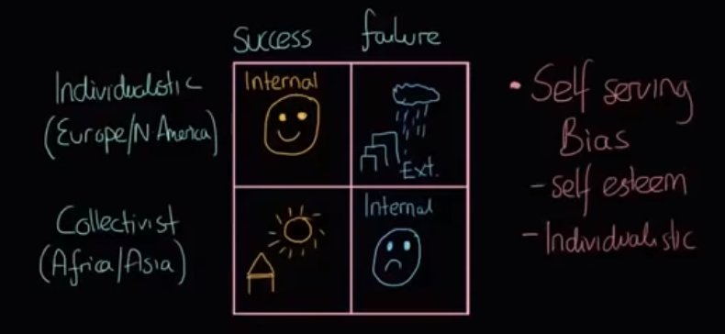

**10.3 Stereotypes, Prejudice, and Discrimination\***

Stereotypes

* **Cognitive**
* Occur when attitudes and impressions are made based on limited and superficial information about a person or a group of individuals
* Stereotype content model

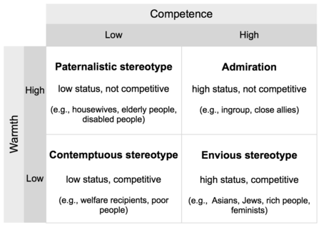

* Can lead to expectations of certain groups → create conditions that lead to confirmation of the stereotype (**self-fulfilling prophecy**)
  + E.g. First year medical students are stereotyped as being unable to quickly and efficiently throw knots during a surgery
* Stereotype threat
  + Concern or anxiety about confirming a negative stereotype about one’s group → may hinder performance → may actually create a self-fulfilling prophecy
  + E.g. white males in sport, homosexual couples providing childcare

Prejudice

* **Affective**
* Defined as an irrational positive or negative attitude toward a person, group, or thing prior to an actual experience
  + E.g. which car manufacturers are most reliable
* May be kept internally or shared with the larger community e.g. via propaganda
* Can be influenced by power, prestige, class

Ethnocentrism

* Refers to the practice of **making judgments about other cultures based on the values and beliefs of one’s own culture**
* Ingroup vs outgroup
* **This is NOT the same as cultural relativism:**
  + Refers to the recognition that social groups and cultures should be studied on their own terms
  + Their rules are just **different, not superior**

Discrimination

* **Behavioral**
* When prejudicial attitudes cause individuals of a particular group to be treated different from others
  + **Individual discrimination**
    - One person discriminating against a particular person or group
  + **Institutional discrimination**
    - An entire institution discriminating against a particular person or group